Week 4

This was the last week of the project – Week Four. This week was very important to finish the product in working code and polished exterior, first I had to nail down the code, my main code idea is motor controlled by human touch. The motor will activate when interact with human touch, As I need my motor to run much slower than the servo motor I have been experiment with in the past, I purchased a Micro Metal Gearmotor as advised by Ali Napier from MAKE LAB. The human touch is represent by the capacitative sensor, which can sense electrical capacitance of human body, connect to motor and Led light by reading the analog write value of motor and digital write value of LED. Every interaction last 10 seconds, create the factor of Change with each interaction.

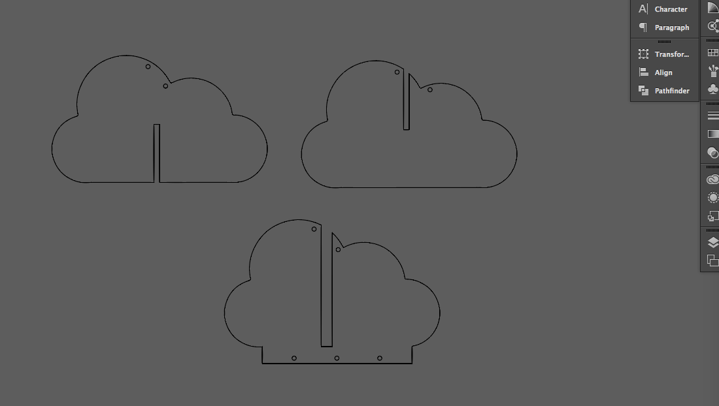
The cloud shape was designed to mimic the effect of kaleidoscope by motor control moving glass panels, however as this was a short project with limited time, I couldn't created the intricate wire structured with fitted small glass panels. Instead I have created a plat packed version of the design use transparent acrylic board with the help of laser cutter for a smooth edge to represent glass panels attached by three brass pipe represent the metal chime. A simpler but still stylish with beautiful material palette experiences prototype.

To assemble the code with the 3D model prototype, I used wood ring from a embroidery ring as the circle frame, gear-motor hanging from top of the ring connected by conductive wire with LED light and flat packed cloud and chime below. The exterior of the product is decorated with gold colour cardboard and dark wood create a strong but harmony contrast appearance. At the very last minute, the weight of the weir are over powering the small base, as show in the video I created a temporary base with two bulldog clips.

The video making was quite difficult, as the time limited, I couldn't build a better prototype which fits all the motor parts within the design, rather than wire hanging from the outside. I tried use sound, hand draw UX map, video effects and add in texts to explain the content better.

